**Report of Conclusions: Crowdfunding Campaigns Data Set**

From the data provided we can conclude that there are three main campaign player categories.

In order of importance, those are: **Film & Video, Music and Theatre,** these are a good representation of the success and failures of the totality of the categories analysed. From the graph below (Fig.1.) we can observe that the proportion of successful project campaigns, against cancelled and failed projects, is of three folds, followed by failed campaigns which comprise around 1.5 folds of the total count. Telling us that in general there is more successful campaigns then not.

**Fig. 1. Category vs Outcome:** Campaign category analysed based on campaign outcome.

Additionally, data suggests, **theatre plays** are for far the main attractor for campaign launching followed far behind by Rock music projects as shown by Fig.2.

**Fig. 2. Subcategory vs Outcome:** Campaign subcategory analysed based on campaign outcome.

Data was also analysed based on the campaign launching date (Fig.3.), this data indicates that months such as May to August are preferred months to launch campaigns and June and July showed the highest successful rates; however further statistical analysis is needed to determine significance.

Other interesting information is that provided by Fig. 4. Which compares outcome vs campaign goal. It shows how campaigns with goals in the range of 15K to 35K are mostly successful looking deeper into the data that might be in part related to the campaigns in this range are not that many compare to those in lower ranges and much; however a further more detailed analysis with a few more graphs comparing also amount of campaigns, for example, will be required to draw more robust conclusions in this subject.

**Fig. 3. Outcome vs Month of Launching:** Campaign outcome compare against month in which the campaign was launched.

**Data analysis**

**Fig. 4. Outcome Based on Goal:** Campaign outcome percentage based on Goals.

The analysis of the Mean and Median of the data when compare against the graphical analysis of it, (Table 1, Fig.5. a and b) showed that the backer count of successful campaigns and failed campaigns is not a normal distribution but a chi distribution being more popular campaigns whit fewer bakers (Fig 5. a and b) for this reason showing the median to represent these populations is a better option over the Mean.

Another interesting fact is that the variance of the successful campaigns is large and almost double that of failed campaigns will be interesting to do further analysis to investigate correlations with the successful rate.

**Table 1. Campaign Outcome Statistical Data.**

|  |  |  |
| --- | --- | --- |
|  | **Successful** | **Failed** |
| **Mean** | 851.15 | 585.62 |
| **Median** | 201 | 114.5 |
| **Min** | 16 | 0 |
| **Max** | 7295 | 6080 |
| **Variance** | 1603374 | 921575 |
| **STDV** | 1267 | 960 |

**b**

**a**

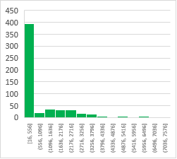 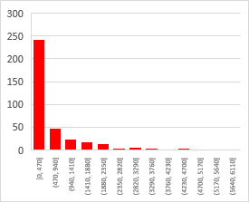

**Summary**

**Fig. 5. Statistical Analysis a: Successful** Campaign vs Backers Count **b: Failed** Campaign vs Backers Count

The data provided for this analysis, present a strong set of information enough to have a big picture of the Crowdfunding Campaigns performance; however, it will be recommendable to have the stakeholders involved once a deeper analysis is carried on in order to get richer stories about categories, subcategories, goals, donations and year of launching as well as the correlations that they might hold.